**Raw-Cache implementation for SOA.**

1. **Initials configuration**
2. Make sure that below changes exists in soa composer of the targeted SOA environment.
3. Add mongoDatabase, mongoURL,CacheConfig parameter in SOA/composer.

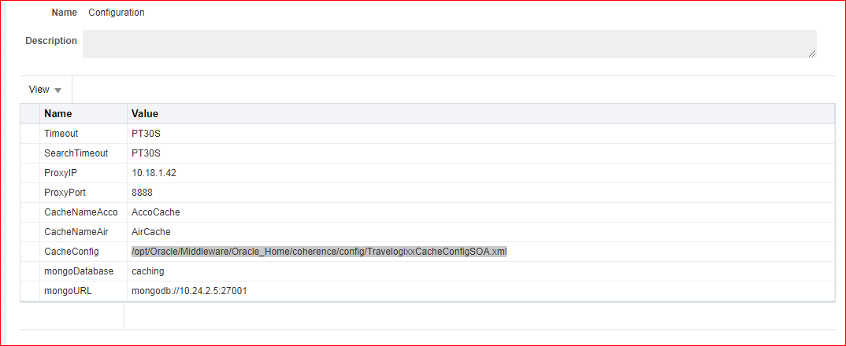

1. The server ip for mongo may change according to the environment.
2. Make sure that the port number between mongo server & soa, osb servers are opened properly & communication should be there.
3. Now copy below files on the server in coherence config folder as they are required for setting it up cache. Sample files are attached with this file.

**Location** : /opt/Oracle/Middleware/Oracle_Home/coherence/config

* + tangosol-coherence-override.xml
  + TravelogixxCacheConfigSOA.xml
  + TravelogixxPOFConfig.xml

1. Change the ips to the respective soa/ osb servers in the file **tangosol-coherence-override.xml.**
2. Now setup the cluster for the coherence on the console. After creating it target the coherence cluster to the soa_servers.
3. Once the cluster is setup take restart of the soa_servers.
4. Make sure that you have copied **cnk-caching.jar, mongo-java-driver-3.4.3.jar** at location $**ORACLE_HOME/soa/soa/modules/oracle.soa.ext_11.1.1/classes.**
5. Need to build oracle.soa.ext.jar.For doing it manually set Ant build path and run ant command in the location (Oracle_Home)\soa\soa\modules\oracle.soa.ext_11.1.1
6. Deploy the SOA composites on the soa servers.
7. Take restart of soa servers.
8. Next step is to add the soa/composer entries for soa composite. Here you need to make sure that you are making correct entries against the correct deployed composite.
9. Following two entries should be added into the soa/composer for saerchWrapper & nonSearch wrapper.
   * Wrapper2
   * SearchWrapper2
10. If the composite is deployed with the default composite then you need to add entry for above two variables like below

e.g **Operation** : Wrapper2

**opURI**: [http://10.25.6.10:8001/soa- infra/services/default/AccoCSWrapper!2.0*soa_8cb37bca-6013-4863-93c0- 63a0e10d1e3b/AccoCSWrapperBPEL_Client_ep](http://10.25.6.10:8001/soa-%09infra/services/default/AccoCSWrapper!2.0*soa_8cb37bca-6013-4863-93c0-%0963a0e10d1e3b/AccoCSWrapperBPEL_Client_ep)

**SupplierID :** ALL

For Search Operation :

1. If the deployed composite is default one then , add the entry like below

**Operation** : SearchWrapper

**opURI:** <http://10.25.6.10:8001/soa-> infra/services/default/AccoSearchCSWrapper/AccoSupplierSearchCSWrapper_Client_ep

1. You can collect these entries by clicking on the deployed composites current version as shown in below screenshot.

